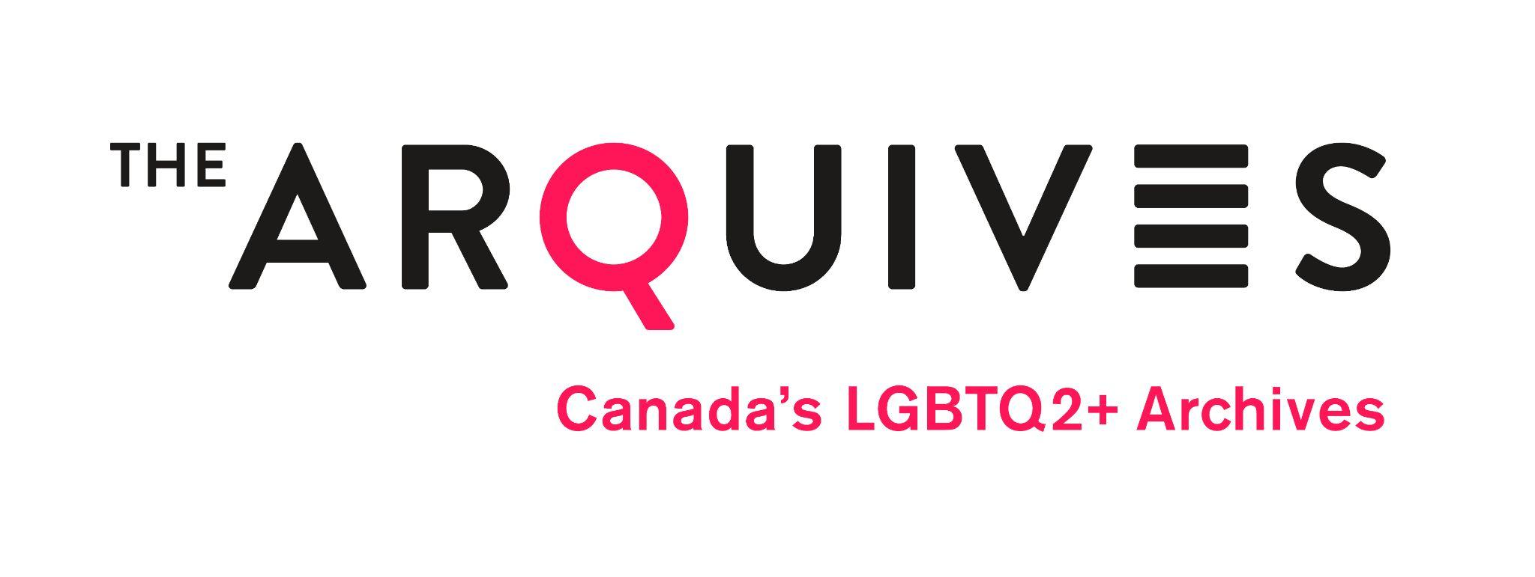
Brief Bio of Nominee

I ______________________________________________ give my consent to be nominated to the Board of Directors of The ArQuives: Canada’s LGBTQ2+ Archives, and agree to commit to the obligations of the Directors if elected. I understand that my commitment is for a two-year term.

_______________________________________________________________
Candidate signature Date

_______________________________________________________________
Nomination Member Date

_______________________________________________________________
Nomination Member Date

