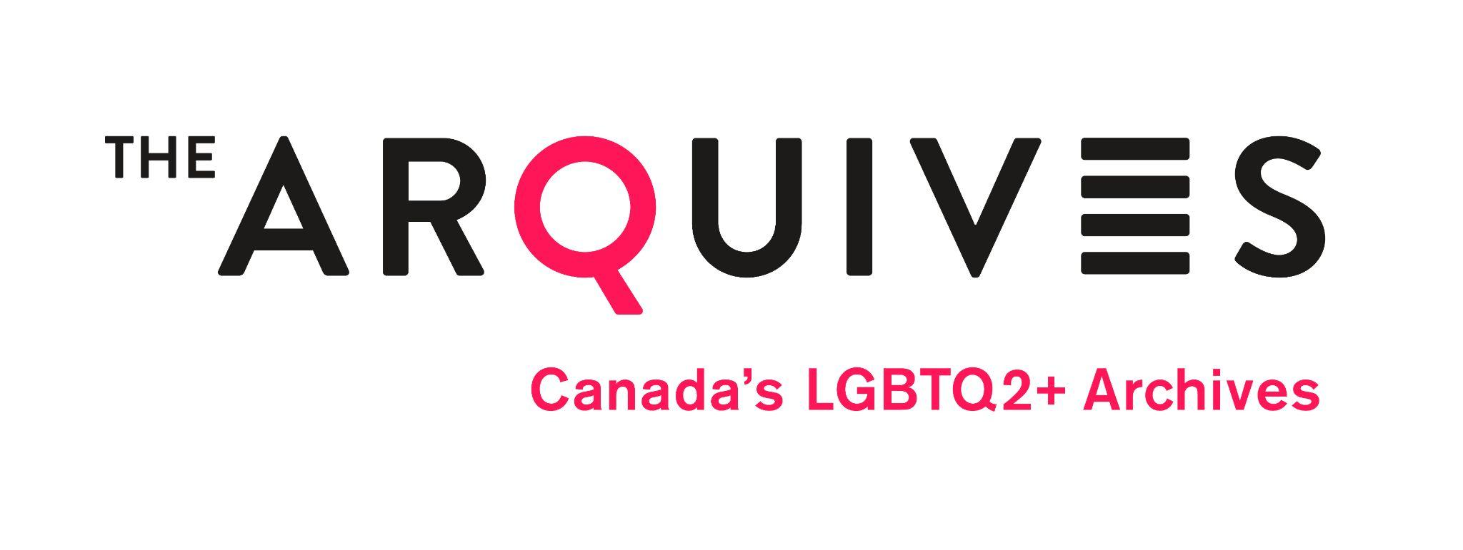
Appointment of Proxy

I ______________________________ of ______________________________ being an eligible voting Member of The ArQuives: Canada’s LGBTQ2+ as defined by the by-law, hereby appoint ___________________________ of ________________________ or failing them the Chair for the time being of the Meeting as my proxy to attend and vote on my behalf at the Annual General Meeting of the organization to be held on the 13th day of May, 2024.

Signed this _______ day of ______________________ 2024.

_________________________________________________
(Signature)

The completed proxy form must be received by the Secretary via email no later than Monday, May 13th, 2024, at 12:00 p.m. (EST). You can direct any questions or your completed form to Michelle Schwartz, Secretary, via email to board@arquives.ca.

